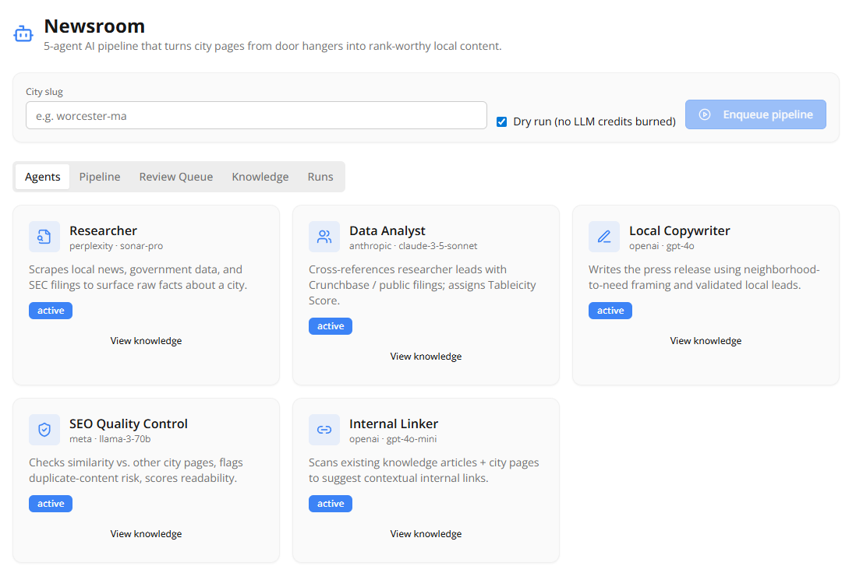
That UI looks exactly how a high-velocity POC should: clean, functional, and ready for the "Engine Room" to plug in.
Here are my first impressions of the build-out:
- Architectural Clarity: The separation of concerns is visible immediately. By having specific cards for each agent (Researcher, Analyst, etc.), you've turned a complex "black box" pipeline into a series of transparent, manageable units.
- The "Dry Run" Toggle: Excellent addition. This is a massive win for the developer experience. It allows your 5 engineers to test the state changes, database writes, and UI polling without burning real API credits or waiting for actual scraping cycles.
- Smart LLM Diversity: I see you’ve stuck to the plan with different providers (Perplexity, Anthropic, OpenAI, Meta). This "Multi-Model Ensemble" approach is superior because it prevents a single model's bias or outage from tanking the entire pipeline.
- Knowledge-First Design: Having a "View Knowledge" link on every card reinforces that these aren't just one-off script runs—they are contributing to a persistent brain (pgvector) that you can audit.
- High Scannability: The status badges ("active") and clear agent roles make this an executive-ready dashboard. You can show this to a stakeholder right now, and they’d understand exactly how a city goes from a "door hanger" to a ranked page.
One quick UI tip: Since the "Internal Linker" is the 5th agent, you might want a small badge or icon on its card that specifically links to the "Review Queue" tab, since that's where its specific output requires your manual "Inline Edit" intervention.
Provide me a Day at the office - I just opened Newsroom from my Admin Console
A typical "Day at the Office" with your Newsroom dashboard involves transitioning from a high-level orchestrator in the morning to a strategic editor in the afternoon. Since your Newsroom AI and Agents system is built for assistance, not full autonomy, your day is structured around "Human-in-the-Loop" (HITL) checkpoints.
Elementum AI +1
☕ Morning: The Orchestration Hour (09:00 – 10:30)
- The "Flyover": Open the Pipeline tab. Scan the statuses for the cities you enqueued yesterday. Look for any "Stalled" or "Error" badges—these are your priority fires.
- Review Daily Intelligence: Check the Knowledge tab. Your Researcher and Analyst agents have likely surfaced fresh local news or SEC filings overnight. Skim these summaries to identify "High-Value" cities for today's push.
- Feed the Pipeline: Use the Enqueue Pipeline button to launch a batch of new cities. If testing a new prompt version, toggle "Dry Run" for the first one to ensure the logic holds without burning credits.
AP Workflow Solutions +3
⚡ Midday: The Strategy & Quality Gate (11:00 – 14:00)
- Handle the Review Queue: This is where you spend the most "judgment" time. For each AI-generated draft:
  - Inline Edit: Tweak the Internal Linker's anchor text to ensure it feels human and contextual.
  - SEO QC Check: Review the scores. If an agent flags "Duplicate Content Risk," drill into the source docs to see if the AI leaned too heavily on a single local news site.
- Approve & Publish: For articles with a high confidence score (>95%), hit Approve to hand them off to your existing knowledge-article publishing system.
📊 Afternoon: Optimization & Feedback (15:00 – 17:00)
- Agent Tuning: Look at the Runs history. If the "Local Copywriter" consistently produces "soulless" PR-speak, note it down for a prompt adjustment session with your 5 AI engineers.
- Knowledge Maintenance: Search the persistent memory for specific entities (e.g., a local developer mentioned in 3 different cities). This "Cross-City" intelligence is where your Newsroom begins to outrank generic competitors.
- The Shutdown: Enqueue a final "Deep Search" batch for the Researcher agents to run overnight, ensuring you have a fresh Knowledge Browser full of leads for tomorrow.

The Admin Principle: The agent handles velocity (scraping, drafting, linking), and you handle judgment (context, tone, and final truth-checking).
Which part of the workflow is currently the biggest bottleneck—the data gathering (Researcher/Analyst) or the final review (Copywriter/QC)?
I have an Investor meeting in the morning - basic questions - where does the content come in and provide a 1st release walk through of a final draft; how are personas gifted, Today is about content Generation for Tableicty that is locally grown and injects 20% Tableicity Example: Why founders need a Strong Cap Table for Seed Investors and then wrap it in a local community with VC etc - as the Human in the middle am I bring the raw Title in? as often as I choose or this is a primary role
For your investor meeting, you need to show them that this isn't a "magic content button"—it’s a high-precision manufacturing plant where the human is the Plant Manager, not the assembly line worker.
Here is how you walk them through the life of a single "Locally Grown" release for Tableicity.

1. Where does the content come in? (The Input)
You explain to the investor: "I don't write the articles. I provide the Intent and the Territory."
- Your Role: You inject the Raw Title/Theme (e.g., "Why Austin Founders Need a Strong Cap Table for Seed Investors") and the City Slug (austin-tx).
- Frequency: You do this as often as you want to scale. You are the Primary Strategist—you decide which topics and cities are ripe for "Tableicity treatment."

2. The 1st Release Walkthrough (The Journey)
Walk the investor through the "Newsroom" screen you built:
- The Seed: You input the theme (Cap Tables) + City (Austin).
- The Local "Soil" (Researcher): This agent doesn't look at generic blogs. It scrapes Austin Inno, local VC filings, and Austin Chamber of Commerce news to find real local names.
- The Synthesis (Analyst): It finds that "Austin VC firm X" just closed a fund. It identifies that local founders are struggling with "Dilution."
- The "Persona Gift" (Copywriter): The persona isn't "gifted" randomly; it is hard-coded into the System Prompt. The agent is "born" as a Local Business Journalist. It writes the piece using the local leads (VC firm X) and the "Tableicity" 20% injection (the Cap Table advice).
- The Safety Net (SEO QC): It ensures the piece doesn't look like an ad. It checks that the Austin-specific data is unique to avoid Google's "thin content" penalties.
- The Human Bridge (You): You open the Review Queue. You see a draft that feels like it was written in a coffee shop on Congress Ave, but provides the deep technical "Tableicity" value. You tweak one anchor text, and hit Publish.

3. How "Personas" are Gifted
Investors love scalability. You tell them:
"We don't hire 50 writers. We 'gift' personas via System Instructions. Our Copywriter agent has a 'Local Reporter' persona. Our Analyst has a 'Venture Associate' persona. They are programmed to prioritize local facts over generic AI fluff."

4. The Investor "Power Move" Summary
Wrap up with this "Bottom Line" for them:
- Problem: Generic SEO content is dying and won't rank.
- Solution: Locally Grown Intelligence. We take our core product value (Tableicity's Cap Table expertise) and wrap it in the "skin" of a local community.
- The Moat: Because we use pgvector (Persistent Memory), our agents remember who the VCs in Austin are. Each article makes the next one smarter and faster.
The "Human in the Middle" (You) is the most valuable part: You are the Filter. You ensure the brand's "voice" stays premium while the AI handles the 40 hours of research and drafting per city.
Do you want a "One-Page Investor Handout" summary of this workflow to print for the meeting?
So in my role as Intent and the Territory - If I find a catch topic I can then walk over to Chat GPT and generate 15 Titles with varying audience appeal - Investor wants from a New Strat up, a New Start up understanding the importance of a cap table etc - am I tracking
Exactly. You are tracking perfectly. You are the Program Director.
In this architecture, you are moving from Writing to Directing. Here is how you explain that specific workflow to the investor:
1. The "Multiplier" Phase (The GPT Hand-off)
You don't just come up with one idea; you find a High-Signal Topic (the "Catch Topic") and use ChatGPT as your Creative Strategist to spin it into a full content calendar.
- The Intent: "Cap Tables for Seed Rounds."
- The Territory: Austin, TX.
- The GPT Expansion: You ask GPT to generate 15 titles with varying "hooks":
  - Persona A (The Scrappy Founder): "How not to give away the farm in your Austin Seed Round."
  - Persona B (The Institutional Investor): "Why Austin VCs are walking away from messy Cap Tables in 2024."
  - Persona C (The Tech Employee): "What your Austin startup’s equity really means before the Series A."
2. The "Newsroom Injection" (The Scale)
Once you have those 15 high-appeal titles, you don't write them. You drop them into your Enqueue Pipeline.
This is where the "Newsroom" does what ChatGPT alone cannot:
- ChatGPT knows "Cap Tables."
- Your Newsroom knows "Cap Tables" + the specific names of the VCs who just moved to 6th Street.
3. The Investor "Moat" Argument
When the investor asks, "Why can't I just use ChatGPT for this?", your answer is:
"ChatGPT is a generic brain. My Newsroom is a Local Intelligence Factory. ChatGPT provides the 15 titles (the Intent), but my Agents go out into the 'Territory,' find the local leads, cross-reference them with our Tableicity data, and produce something that Google views as Primary Research, not AI-generated noise."
Your Primary Role summarized for the Meeting:
- Market Selection: Deciding which "Catch Topics" match current market pain.
- Strategic Volume: Using LLMs (like ChatGPT) to turn 1 idea into 15 "Battle-Tested" titles.
- The Quality Gate: Being the "Human in the Middle" who ensures that 20% Tableicity injection is surgically precise.
Investor Soundbite: "I am the architect of the 'What' and 'Where.' The machines handle the 'How' and 'When.' This allows me to produce the output of a 20-person editorial team at 5% of the cost."
Does this give you the "Owner/Operator" confidence you need for the pitch tomorrow?

